TECHNICAL PROJECT REPORT

# Title of Invention / Project:

***BLIND CAP***

Team Members / Inventors:

|  |  |  |  |  |  |
| --- | --- | --- | --- | --- | --- |
| **S. No.** | **Name** | **Department** | **Designation** | **Mobile** | **E-Mail** |
| 1. | Rafel Ahmed | Cse IBM | Student | 8721031254 | Rafelahmed005@gmail.com |
| 2. | Utsav Ghosh | Cse IBM | Student | 8167606799 | putuutu190@gmail.com |
| 3. | Harsh | Cse IBM | Student | 7015434670 | hs848648@gmail.com |
| 4. | Akash Gupta | Cse IBM | Student | 7607771280 | akash1280gupta@gmail.com |
| 5. | Khushal Thakur | ECE | Mentor | 9646030764 | khushal.thakur@cumail.in |
| 6. | Anshul Sharma | ECE | Mentor | 9478697475 | anshulsharma.ece@cumail.in |
| 7. | Kiran Jot Singh | ECE | Mentor | 9463909689 | kiranjotsingh.ece@cumal.in |
| 8. | Divneet Singh Kapoor | ECE | Mentor | 9878422653 | divneet.ece@cumail.in |

***Section – 1 (IPR Related)***

# Brief Abstract :

It allows the visually impaired person to lead a better and safe time when outside home.This cap enables them to skip various obstacles that comes on their way.

To solve the problem of the visually impaired person and to safeguard them,we have fitted an ultrasonic sensor on a cap.This sensor is connected to an arduino and to a buzzer.The arduino is being powered by a 5 V battery.When any obstacles comes in their way the ultrasonic sensor detects it and the buzzer gives a warning to the person so that He or She would change his or her way and no mishappen happens.**.**

We can add GPS system in this device to help them know if they are going in right direction or not. It can also help their family mates to trace their location.

# Existing state-of-the-art and Drawbacks in existing state-of-the-art

|  |  |  |
| --- | --- | --- |
| **S. No.** | **Existing state of art** | **Drawbacks in existing state of art** |
| 1. | ultrasonic guiding gloves | Unstable because user can mave movements from their hands so it can detect even the unnecessary obstacles. |
| 2. | ultrasonic blind guiding belt | Can only detect upto a certain height. |

# Features

* Detects obstacles to an appropriate height i.e. up to to height of the person.
* Stable due to less movements of head.

# Advantages

* Easy to wear & use.
* It will help blind people when they are walking outside from their home.

# Block Diagram

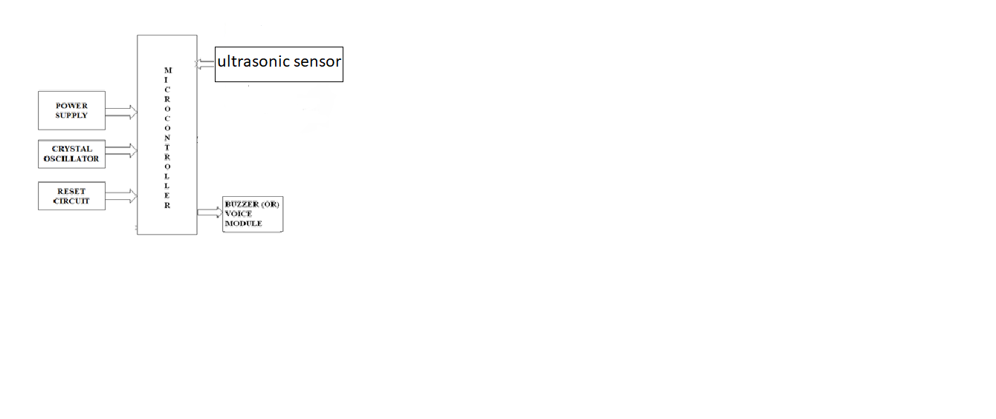

***Section – 2 (Real Project)***

# Materials

|  |  |  |  |
| --- | --- | --- | --- |
| S no. | ITEM | QUANTITY | PRICE |
| 1. | Arduino UNO | 1 | 450(approx) |
| 2. | Ultrasonic sensor | 1 | 120(approx.) |
| 3. | buzzer | 1 | 20(approx.) |
| 4. | battery | 1 or 2 | 15 each |
| 5. | Jumper wires | 2m | 3rs/m |
| 6. | cap | 1 | 100 |

# Steps of Circuit Completion

STEP 1: First of all make secure & correct connections of arduino & ultrasonic sensors.

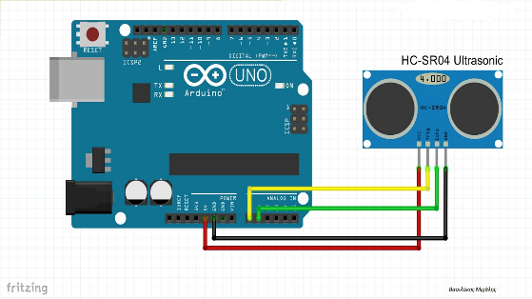

STEP 2: Make sure that the ultrasonic sensor & Arduino is working correctly.

STEP 3: Connect the buzzer with Arduino & ultrasonic sensor correctly.

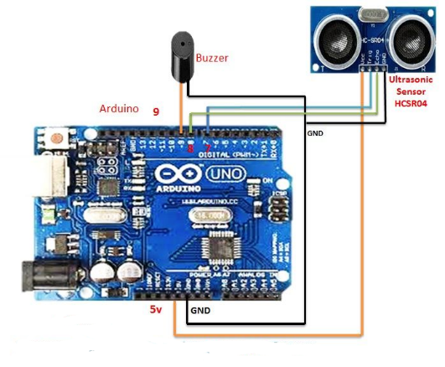

STEP 4: Write the programme defining suitable distance for sensor & upload it, after uploading we can unplug Arduino from PC & supply power through external source(Here we use 9v battery).

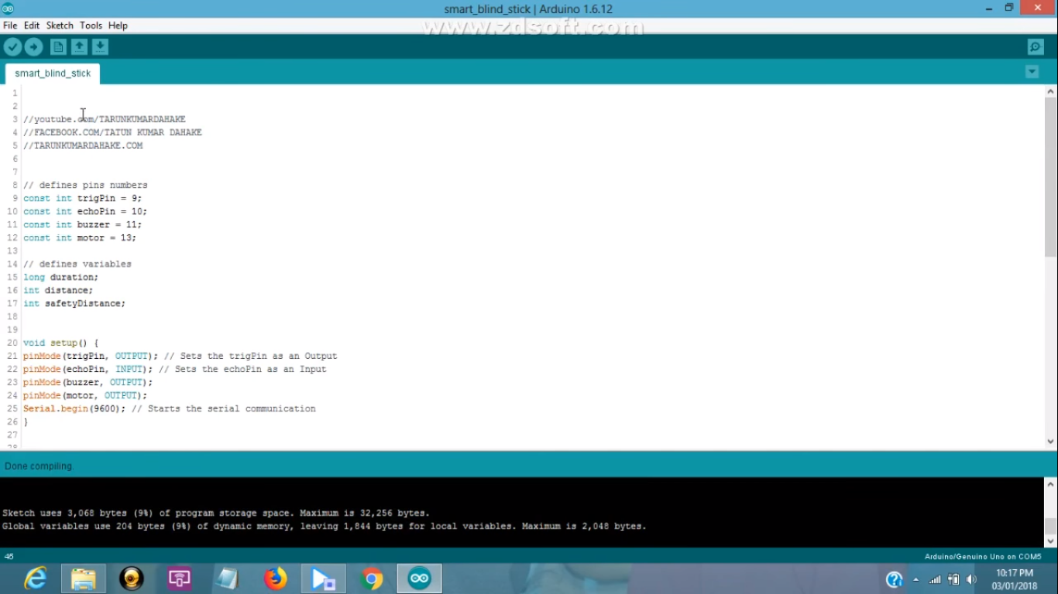

Step 5: Once everything is working correctly, make your connections tight using iron soldring.

Step 6: Your circuit is ready. Now, fix it into a cap (Show your creativity here. BEST OF LUCK).

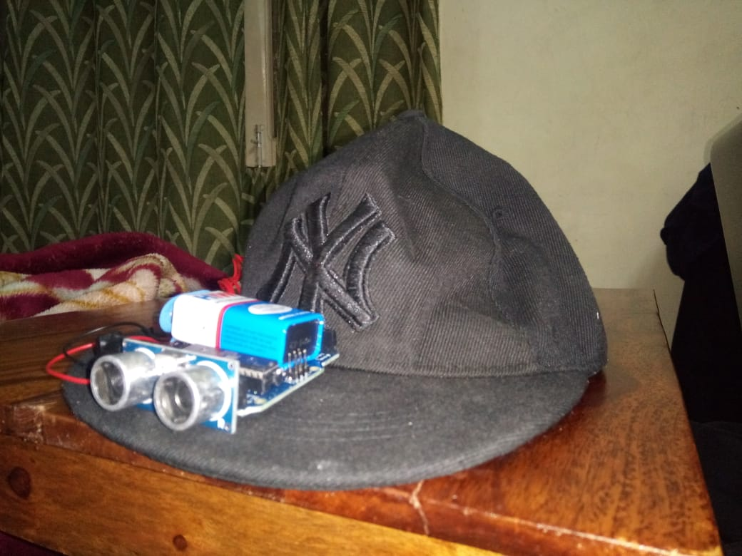

# Circuit Diagram

buzzer

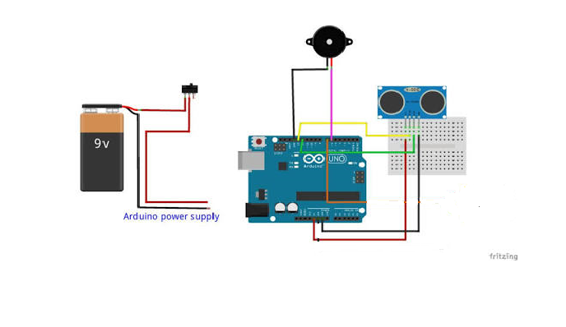

Ultrasonic sensor

switch

# Programme code

<https://github.com/harsh3338/Blind-cap-programme/blob/master/README.md> (code)